Key Considerations: EU Deforestation Regulation (EUDR)
erica0412
Jul 1, 2024
2 min read

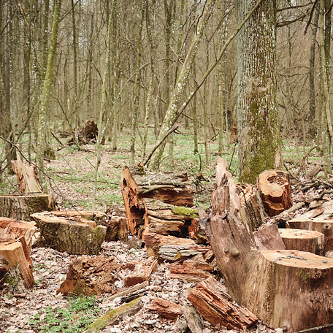

Starting in December 2024, the EU Deforestation Regulation (EUDR) will replace the EU Timber Regulation (EUTR). EUDR aims to minimize the environmental impact of consumer goods by promoting the consumption of ‘deforestation-free’ products which is expected to bring down greenhouse gas emissions and biodiversity loss.

What is the EUDR?

Like the Carbon Border Adjustment Mechanism (CBAM), the EUDR is designed to mitigate the environmental impact of products originating from or produced outside the EU.

This regulation sets forestry standards for imported goods and disqualifies suppliers who fail to meet these standards. Additionally, exporters from the EU must demonstrate that their cargo has not contributed to forest degradation.
The affected commodities include cocoa, coffee, rubber, soy, beef and timber, as well as derivatives such as processed meats, leather, chocolate, soybeans, paper, and printed books. Please note that this list is not exhaustive, and existing EU green supply chain initiatives, like the Forest Law Enforcement Government and Trade (FLEGT) license for paper from certain sources, may still apply in conjunction with EUDR.

What are The Aims of EUDR?

- avoid contribution to deforestation and forest degradation in the EU and globally
- reduce carbon emissions caused by EU consumption and production of the relevant commodities by at least 32 million metric tonnes a year
- address all deforestation driven by agricultural expansion to produce the commodities in the scope of the regulation, as well as forest degradation

What’s Required of Your Suppliers Under the EU Deforestation Regulation (EUDR)?

You must provide exact coordinates showing where the timber products in your shipment originated, ensuring the land was not deforested after 2020.
Beyond deforestation regulations, EUDR mandates that suppliers adhere to standards related to welfare, biodiversity protection, anti-corruption, and the rights outlined in the UN Declaration on the Rights of Indigenous People. Furthermore, EUDR requires that any deforestation complies with the legal standards of the country of origin. According to a report from the Forest Policy Trade and Finance Initiative, only about 30% of commercial deforestation between 2013 and 2019 was legal.

Your Obligations & Risks as an EU Trader

Although the responsibility lies with your suppliers to meet the EU Deforestation Regulation standards, you are accountable for placing these goods on the EU market.
Thus, you must perform due diligence on suppliers and provide a statement to your national authority confirming this.

Your due diligence should include:

- Collecting detailed info to ensure your products comply.
- Conducting a risk assessment for each product.
- Implementing risk mitigation measures, such as independent surveys and working with suppliers on improvements.

If a supplier fails to meet EUDR requirements, you must find an alternative that does.
As the importer, you are responsible for issuing a statement proving due diligence for each import shipment and passing the reference number of the statement to any downstream operators in your supply chain. A similar statement is required for EUDR goods exported from the EU.

Compliance checks from your national authority, may come without warning and they may demand immediate corrective action if noncompliance is found.

Non-compliance can result in:

- Confiscation of goods.
- Temporary exclusion from public procurement and funding.
- Temporary prohibition from trading EUDR goods.
- Increased due diligence reporting requirements.
- Fines of up to 4% of your previous year’s EU turnover.

